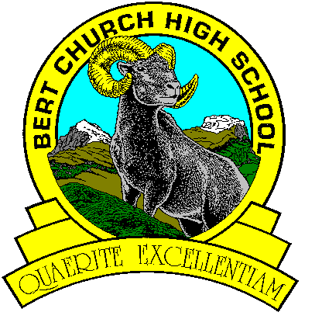

Science 24
Course Outline
Ms. E. Lahl

Goals
The goals of the Science 14-24 program are:
- encourage students at all grade levels to develop a critical sense of wonder and curiosity about scientific and technological endeavors
- enable students to use science and technology to acquire new knowledge and solve problems, so that they may improve the quality of their own lives and the lives of others
- prepare students to critically address science-related societal, economic, ethical and environmental issues
- provide students with a foundation in science that creates opportunities for them to pursue progressively higher levels of study, prepares them for science-related occupations, and engages them in science-related hobbies appropriate to their interests and abilities
- enable students, of varying aptitudes and interests, to develop a knowledge of the wide spectrum of careers related to science, technology and the environment.

Course Evaluation

Science 24 has been set up to be an inquiry based course that will be looking at the curriculum outcomes and will require in class participation. Investigations and research are a key component to Science 24 and will be presented by students in different ways and formats based on their learning styles and preferences. Assessment will happen throughout the class periods in practical and virtual labs, assignments, lab reports, reflections and moodle assessments.

Course Evaluation

Unit A: Applications of Matter and Chemical Change
Unit B: Understanding Common Energy Conversion Systems
Unit C: Disease Defence and Human Health
Unit D: Motion, Change and Transportation Safety

Category Evaluation

Unit Performance Task 40%
Outcome Based Assessment 60%
Science Department Intervention
Science classes will integrate opportunities for reassessment throughout the semester in their respective courses. These will be communicated to students.
Students that are not passing or have not met deadlines for assignments or evaluations must complete an intervention plan in consultation with the teacher and parent.
Intervention week will proceed, as directed, at the end of the semester.
Grade 10-12 students who are not passing are required to attend to receive targeted support to be re-assessed or to complete assignments on curricular outcome(s) that would have a substantial impact on course grade
Grade 10-12 students who are passing may choose to attend to be re-assessed or to complete assignments on curricular outcome(s) that would have a substantial impact on course grade.

Materials

Duotang, loose-leaf paper, pen, pencil, eraser, scientific calculator
Text: Science Connect 2., McGraw-Hill Ryerson ($102.25)

Science Department Expectations

Please refer to the student handbook for all school policies. Additionally, these are expectations specific to the science department:

Late Procedure

It is reasonable to expect each student to be punctual for each class period. Repeated lateness is disruptive to learning and discourteous and, if not corrected, tends to become commonplace. Corrective action may include detention time, parent intervention or in chronic situations referral to administration.

Missed Assessments

When a student is absent it is their responsibility to contact the teacher about missed work and to determine a mutually agreeable time for missed assessments to be completed. If no attempt is made to contact the teacher within one day of the student’s return, or the work is not completed within agreeable time, a zero will be given.

Calculator Policy

It is the student’s responsibility to have an appropriate calculator for tests, quizzes, and assignments.

Calculators may be used for exams/quizzes, but may not be shared.

Calculators will not be lent out to students by their teacher.

No information, text, or formulas may be stored in electronic form.

Calculators will be cleared before quizzes, exams, and final exams.

Appeals

Students and parents may direct, in writing, any appeal of the final grade to the school Principal (see page 19 of the student handbook).

