Robotics 9
Ms. R Kisinger
rkisinger@rockyview.ab.ca (parent)
rkisinger@rvschools.ca (student)
403.948.3800 ext. 2885

COURSE DESCRIPTION:
This course is a grade 9 option course. The focus of this course is to introduce students to design, drafting and coding all through the use of Sphero robots.

EXPECTATIONS
ATTENDANCE:
This course is focused on the learning process rather than the final product. Most of the work in this course will be completed and assessed during class. This means that attendance is vital to success in the course. If it is impossible for you to be in class one day please ensure that your parents or guardian calls into the school the day of your absence to excuse you. You will be responsible for making up the work you missed during extra help hours once you are back at school. If you know ahead of time that you will be missing class please discuss your absence with Ms. Kisinger so a plan can be made for you to work ahead.

COLLABORATION:
Group work is an essential component of most STEAM careers. Throughout this course, you should expect to rotate through groups so you have the opportunity to work with all of your classmates.

PREPARATION:
Please do not bring other supplies such as backpacks or coats unless requested because we will often be up and moving around the classroom completing activities. If you will need any other supplies, you will be informed ahead of time.

EXTRA HELP:
Extra help is available from the course instructor in flex and after school. It is the responsibility of the student to recognize when extra help is needed and then contact the course instructor.

ASSIGNMENTS:
Students can expect to complete approximately 5 assignments throughout the semester; each assignment is equally weighted. That means that each assignment is worth a significant amount of your mark. Please ensure you are putting your best foot forward in each assignment to ensure your own success.

ASSESSMENT AND GRADING
The course is graded using standards based grading. The standards being assessed are from The 21st Century Competencies defined by Alberta Education as listed below.

- Collaboration and Leadership
- Critical thinking and problem solving
- Creativity and Innovation
- Communication
- Digital and Technological Fluency
- Lifelong Learning and Personal Management

Each assignment is assessed using the scale listed below:

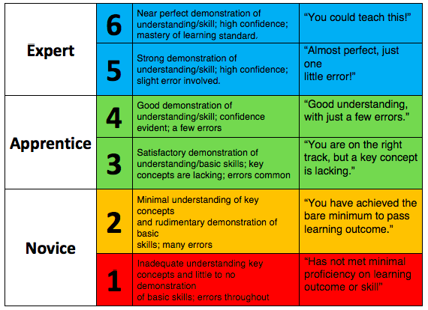

I wish you the best of luck in Robotics 9 this quarter. Please do not hesitate to come to me with any questions, comments, or concerns you may have, whether they pertain to this course, another course or anything else. I look forward to working with you in creating an engaging, and enriching classroom environment and the development of your skills throughout the semester.

